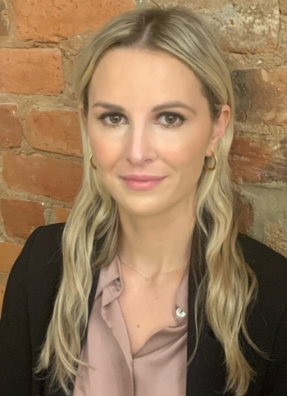
VICTORIA E. STEAD, PhD., C.Psych
Victoria E. Stead is a Psychologist and the former Clinical Lead for the Young Adult Substance Use Program within the Concurrent Disorders Outpatient Service at St. Joseph’s Healthcare Hamilton and an Adjunct Professor in the Department of Psychiatry & Behavioural Neurosciences at McMaster University.

