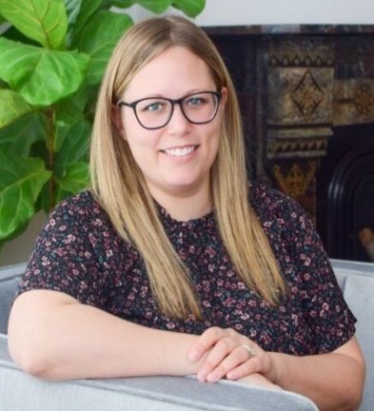
STEPHANIE KOLASKI, RP, PMH-C
Stephanie is a Registered Psychotherapist with 10 years of experience supporting individuals with mental health and addiction. Stephanie has worked in a variety of settings such as community and residential programming, hospital and emergency departments, and is currently in private practice. Stephanie’s practice focuses on supporting individuals with anxiety, depression, and OCD, with a specific passion for the perinatal population. Stephanie holds a Perinatal Mental Health certification through Postpartum Support International. Additionally, Stephanie provides supervision to Qualifying RPs, and is an instructor within Mohawk College’s Continuing Education program.

