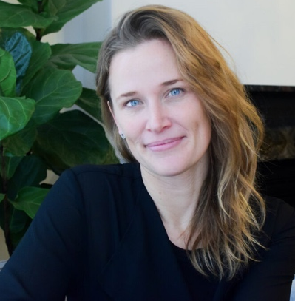
ELISHA SCHAFER, MSc, RP
Elisha Schafer is a Registered Psychotherapist, dedicated to providing clinical leadership, supervision, and program management in both private and public healthcare environments. She currently owns and operates a multi-practitioner private psychotherapy practice.

